Pujan Shrestha (E2400005) – Use Case 2, Use Case 5

UC2 – Manage Food Inventory
Epic
As a user, I want to easily manage my food inventory, I want to know what food is available, when it will expire and food will be waste.
User Story 1: Add Food Item

[User Story 1] | As a user,  I wish to add food to my stock,  To ensure I can see what food I have at my disposal at this time.
Acceptance Criteria | If I am logged in to the system and click on "Add Food Item", I should be able to enter the name of the food, quantity, expiry date, category and storage location.  Given I have entered all required information, when I click "Save", then the food item should be added to my inventory.  Given a food item has been successfully added, when I view my inventory, then the new item should appear in the list.
MoSCoW | Must Have (M)
Tasks | - Design Add Food Item form.  - Validate user input.  - Store food item information in the database.  - Display confirmation message.
Test Cases

User Story 2: Edit Food Item
[User Story 2] | As a user,  I want to edit existing food items,  So that my inventory information remains accurate and up to date.
Acceptance Criteria | If there are food items in my inventory, then when I select an item and click "Edit", then I should have the ability to edit the details of that item.  As I've updated the food item information, and subsequently saved the changes, the inventory should show the new information.  Given I have completed editing, when I return to the inventory page, then the updated item should be visible.
MoSCoW | Must Have (M)
Tasks | - Create Edit Food Item functionality.  - Update records in the database.  - Refresh inventory display.
Test Cases

User Story 3: Delete Food Item
[User Story 3] | As a user,  I want to delete food items from my inventory,  So that outdated or consumed items are removed.
Acceptance Criteria | Given food items exist in my inventory, when I select a food item and click "Delete", then the system should ask for confirmation.  If I confirm deletion, then when the delete action is completed, selected item should be deleted from inventory.  Given the item has been deleted, when I view my inventory, then the item should no longer appear.
MoSCoW | Must Have (M)
Tasks | - Create Delete functionality.  - Implement confirmation dialog.  - Remove food item from database.
Test Cases

User Story 4: Receive Expiry Alerts
[User Story 4] | As a user,  I want the system to notify me when food items are close to their expiry dates,  So that I can consume, donate, or use them before they expire.
Acceptance Criteria | Given a food item is approaching its expiry date, when the notification threshold is reached, then the system should generate an alert.  Given an expiry alert exists, when I open the application, then I should be able to view the alert.  If I have seen the alert, then as a result of taking action on the alert, the alert notification's status should be updated.
MoSCoW | Must Have (M)
Tasks | - Implement expiry date tracking.  - Create notification generation logic.  - Display alerts on dashboard.
Test Cases

UC5 – View Notifications
Epic
As a user, I want to receive and manage notifications so that I can stay informed about food expiry dates, donation updates, and important reminders.

[User Story 1] | As a user,  I want to receive expiry date notifications,  So that I can consume food before it becomes spoiled.
Acceptance Criteria | Given food items are approaching expiry, when the notification threshold is reached, then the system should send an expiry notification.  Given I receive a notification, when I open it, then I should be able to view detailed information.  If I have read the notification, then when I dismiss it, it shouldn't be displayed as unread.
MoSCoW | Must Have (M)
Tasks | - Generate expiry notifications.  - Create notification panel.  - Display notification details.
Test Cases

User Story 2: View Donation Status Updates
[User Story 2] | As a user,  I want to receive donation status updates,  So that I know whether my donated food has been accepted or collected.
Acceptance Criteria | Given I have donated food, when the donation status changes, then the system should generate a notification.  Given a donation update notification exists, when I access notifications, then I should see the latest donation status.  Given I have viewed the update, when I dismiss the notification, then it should be marked as completed.
MoSCoW | Should Have (S)
Tasks | - Track donation status changes.  - Generate status notifications.  - Update notification history.
Test Cases

User Story 3: Manage Notification Preferences
[User Story ] | As a user,  I want to manage my notification preferences,  So that I only receive notifications relevant to me.
Acceptance Criteria | Given I am in the notification settings page, when I enable or disable a notification type, then my preferences should be saved.  Given I have disabled a notification category, when an event occurs, then the system should not send that notification.  Given I have updated my preferences, when I revisit the settings page, then my saved preferences should be displayed.
MoSCoW | Could Have (C)
Tasks | - Create notification settings page.  - Save user preferences.  - Update notification delivery rules.
Test Cases

Design Specification Document (Group Work)

Architectural Design
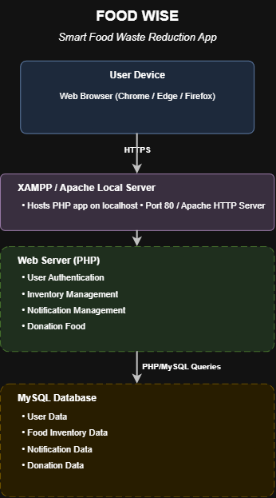
Fig. Deployment Architecture — FoodWise

High-Level Design Components
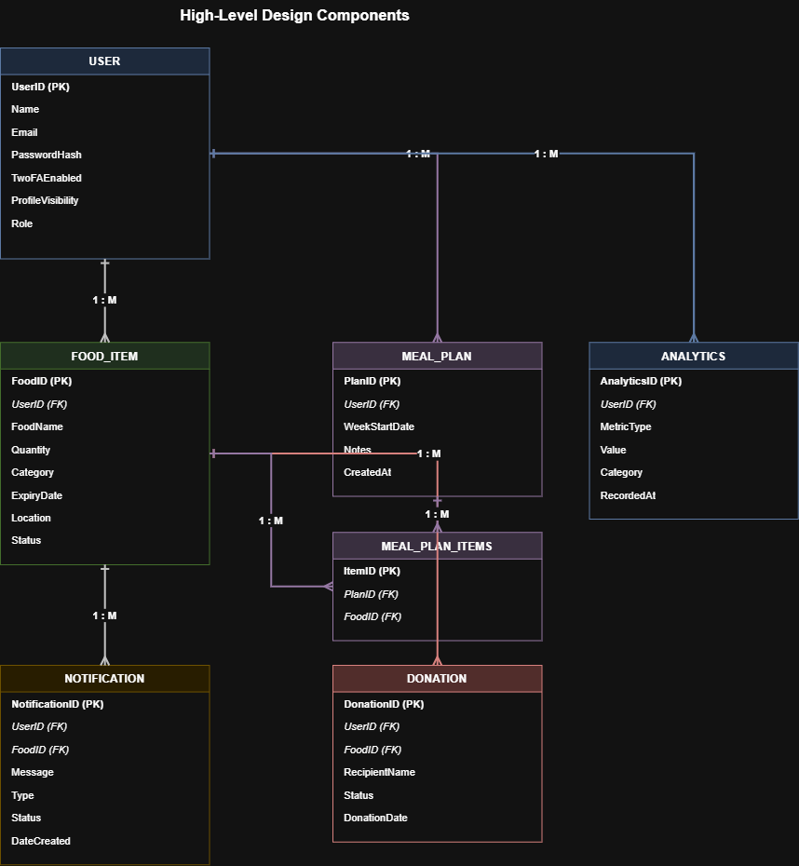
Fig. High-Level Design Components / Entity Relationship Diagram — FoodWise

Site Map
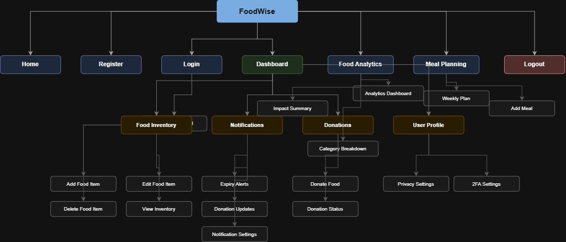
Fig. Site Map — FoodWise

Database Design (Data Dictionary)
DATABASE DESIGN (DATA DICTIONARY)

Table: USER
Field Name | Data Type | Key | Description
UserID | INT | PK | Unique User ID
Name | VARCHAR(100) | - | User Full Name
Email | VARCHAR(100) | - | User Email
Password | VARCHAR(255) | - | Encrypted Password
TwoFAEnabled | TINYINT(1) | - | Two-Factor Authentication enabled flag (0=disabled, 1=enabled). Default: 0
TwoFACode | VARCHAR(10) | - | One-time 2FA verification code. Nullable
TwoFAExpiry | DATETIME | - | Expiry timestamp of the 2FA code. Nullable
ProfileVisibility | ENUM | - | Controls profile visibility: public or private. Default: public
CreatedAt | DATETIME | - | Account creation timestamp. Default: CURRENT_TIMESTAMP

Table: FOOD_ITEM
Field Name | Data Type | Key | Description
FoodID | INT | PK | Unique Food Item ID
UserID | INT | FK | References User
FoodName | VARCHAR(100) | - | Food Name
Quantity | INT | - | Food Quantity
Category | VARCHAR(50) | - | Food Category
ExpiryDate | DATE | - | Expiry Date
Location | VARCHAR(50) | - | Storage Location

Table: NOTIFICATION
Field Name | Data Type | Key | Description
UserID | INT | FK | References USER.UserID — identifies the user receiving the notification
NotificationID | INT | PK | Unique Notification ID
FoodID | INT | FK | References Food Item
Message | TEXT | - | Notification Content
Status | VARCHAR(20) | - | Read / Unread
CreatedDate | DATETIME | - | Notification Creation Date

Table: DONATION
Field Name | Data Type | Key | Description
DonationID | INT | PK | Unique Donation ID
FoodID | INT | FK | References Food Item
DonationDate | DATE | - | Date of Donation
Status | VARCHAR(30) | - | Pending / Accepted / Collected

Table: MEAL_PLAN
Field Name | Data Type | Key | Description
MealPlanID | INT | PK | Unique Meal Plan record ID. Auto Increment
UserID | INT | FK | References USER.UserID — owner of the meal plan
MealName | VARCHAR(100) | - | Name of the planned meal
PlannedDate | DATE | - | Date the meal is planned for
DayOfWeek | ENUM | - | Day of the week: Mon, Tue, Wed, Thu, Fri, Sat, Sun
MealSlot | ENUM | - | Meal time slot: Breakfast, Lunch, Dinner, Snack
Notes | TEXT | - | Optional notes or cooking instructions for the meal. Nullable
CreatedAt | DATETIME | - | Record creation timestamp. Default: CURRENT_TIMESTAMP

Table: MEAL_PLAN_ITEMS
Field Name | Data Type | Key | Description
MealItemID | INT | PK | Unique Meal Plan Item record ID. Auto Increment
MealPlanID | INT | FK | References MEAL_PLAN.MealPlanID — the meal this item belongs to
FoodID | INT | FK | References FOOD_ITEM.FoodID — the food item used in this meal
QuantityUsed | INT | - | Quantity of the food item reserved/used for this meal

